The original Classification Group

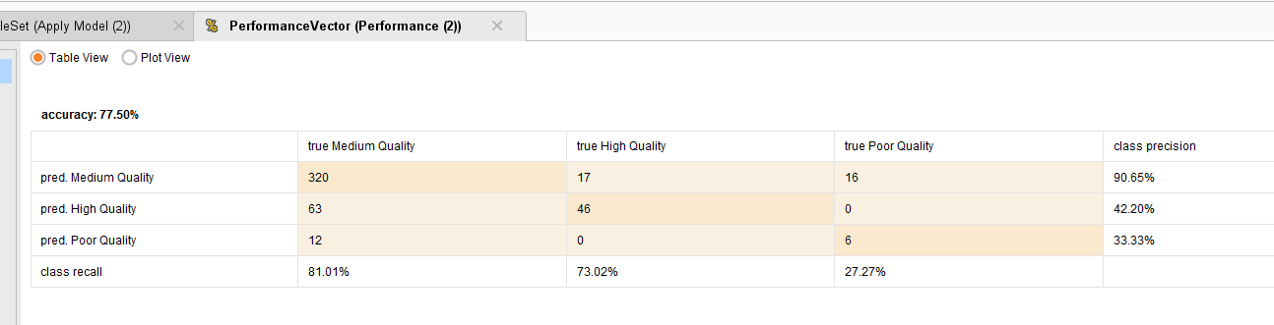

The changed Classification.. if([quality]<=5, "Poor Quality",if([quality]>5 && [quality]<=7,"Medium Quality",if([quality]>7,"High Quality","Uncategorised")))

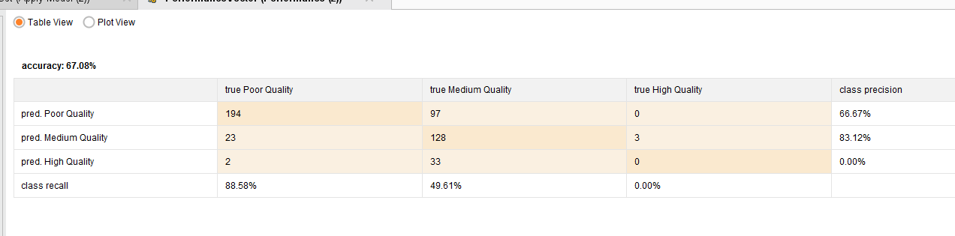

if([quality]<5, "Poor Quality",if([quality]>=5 && [quality]<7,"Medium Quality",if([quality]>=7,"High Quality","Uncategorised")))

if([quality]<5, "Poor Quality",if([quality]>=5 && [quality]<7,"Medium Quality",if([quality]>=7,"High Quality","Uncategorised")))

